Java Swing and Menus

Feature | AWT | Swing
Full form | Abstract Window Toolkit | Swing
Package | java.awt | javax.swing
Introduced | Java 1.0 | Java 1.2
Component type | Mostly heavyweight | Mostly lightweight
OS dependency | Uses native OS components | Mostly drawn/managed by Java
Look & Feel | Depends more on OS | Pluggable Look & Feel
Components | Limited/basic | Rich and extensive
Button | Button | JButton
Label | Label | JLabel
Text field | TextField | JTextField
Text area | TextArea | JTextArea
Checkbox | Checkbox | JCheckBox
Radio button | Checkbox + CheckboxGroup | JRadioButton + ButtonGroup
List | List | JList
Table | ❌ No JTable equivalent | ✅ JTable
Tree | ❌ No JTree | ✅ JTree
Tabs | ❌ No direct equivalent | ✅ JTabbedPane
Slider | ❌ No direct equivalent | ✅ JSlider
Progress bar | ❌ No direct equivalent | ✅ JProgressBar
Dialog | Dialog | JDialog, JOptionPane
Scroll pane | ScrollPane | JScrollPane
Customization | Less | More
Portability of appearance | Appearance may vary by OS | More consistent appearance
Suitable for | Basic GUI learning/applications | Rich desktop GUI applications

JButton
It is a Swing component that represents a button which performs an action when clicked.

import javax.swing.*;

public class ButtonExample {
public static void main(String[] args) {
JFrame f = new JFrame("JButton");

JButton b = new JButton("Click Me");
b.setBounds(100, 80, 120, 40);

b.addActionListener(e -> JOptionPane.showMessageDialog(f, "Button Clicked"));
// JOptionPane is a Java Swing class used to create ready-made dialog boxes.
f.add(b);

f.setSize(300, 250);
f.setLayout(null);
f.setVisible(true);
f.setDefaultCloseOperation(JFrame.EXIT_ON_CLOSE);
}
}

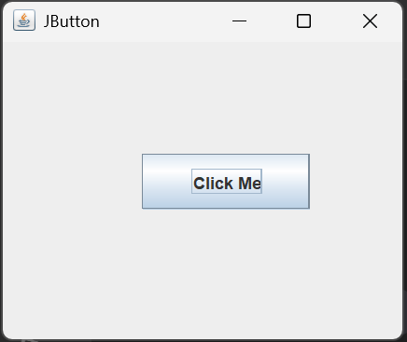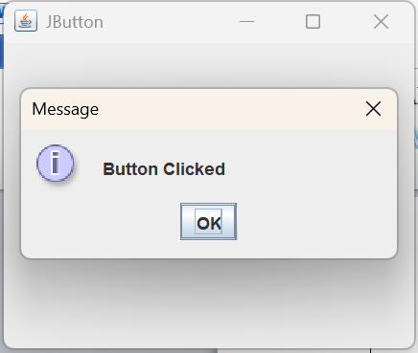
Traditional version using ActionListener
b.addActionListener(new ActionListener() {
public void actionPerformed(ActionEvent e) {
JOptionPane.showMessageDialog(f, "Button Clicked");
}
});
The lambda expression is simply the shorter form of the above code.
JLabel
It is a Swing component used to display text, images, or both

import javax.swing.*;

public class LabelExample {
public static void main(String[] args) {
JFrame f = new JFrame("JLabel");

JLabel l = new JLabel("Hello Java");
l.setBounds(100, 80, 150, 40);

f.add(l);

f.setSize(300, 250);
f.setLayout(null);
f.setVisible(true);
f.setDefaultCloseOperation(JFrame.EXIT_ON_CLOSE);
}
}

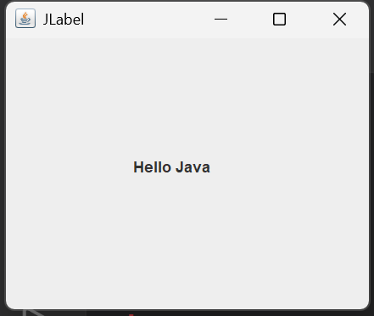
JTextField
It is a Swing component that allows the user to enter and display a single line of text.

import javax.swing.*;

public class TextFieldExample {
public static void main(String[] args) {
JFrame f = new JFrame("JTextField");

JTextField t = new JTextField();
t.setBounds(80, 50, 150, 30);

JButton b = new JButton("Show");
b.setBounds(100, 100, 100, 30);

b.addActionListener(e ->JOptionPane.showMessageDialog(f, t.getText())
);

f.add(t);
f.add(b);

f.setSize(300, 250);
f.setLayout(null);
f.setVisible(true);
f.setDefaultCloseOperation(JFrame.EXIT_ON_CLOSE);
}
}

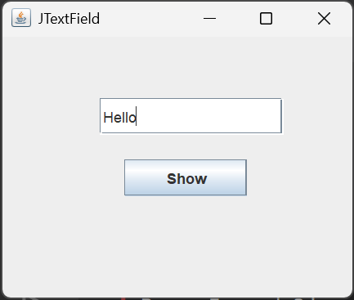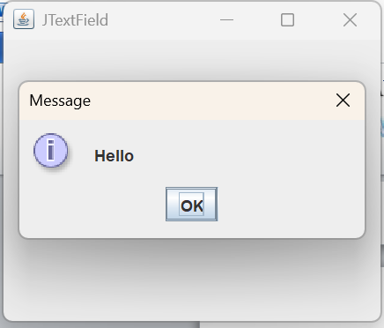
JPasswordField
It is a Swing component that allows the user to enter a password while hiding the entered characters.

import javax.swing.*;

public class PasswordExample {
public static void main(String[] args) {
JFrame f = new JFrame("JPasswordField");

JPasswordField p = new JPasswordField();
p.setBounds(80, 50, 150, 30);

JButton b = new JButton("Login");
b.setBounds(100, 100, 100, 30);

b.addActionListener(e->JOptionPane.showMessageDialog(f,"Password Entered")
);

f.add(p);
f.add(b);

f.setSize(300, 250);
f.setLayout(null);
f.setVisible(true);
f.setDefaultCloseOperation(JFrame.EXIT_ON_CLOSE);
}
}

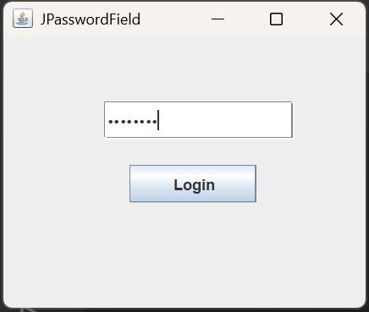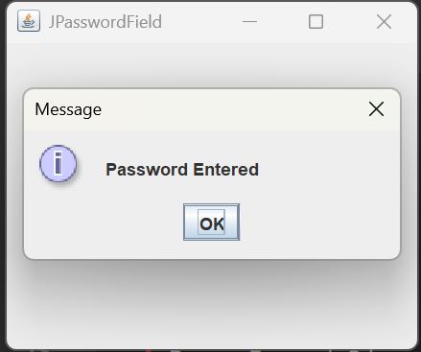
JTextArea
It is a Swing component that allows the user to enter and display multiple lines of text.

import javax.swing.*;

public class TextAreaExample {
public static void main(String[] args) {
JFrame f = new JFrame("JTextArea");

JTextArea a = new JTextArea();
a.setBounds(50, 50, 200, 100);

f.add(a);

f.setSize(300, 250);
f.setLayout(null);
f.setVisible(true);
f.setDefaultCloseOperation(JFrame.EXIT_ON_CLOSE);
}
}

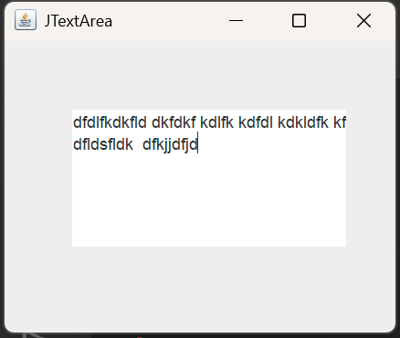
If you want scrollbars then
JTextArea a = new JTextArea();
JScrollPane sp = new JScrollPane(a);

f.add(sp);
JCheckBox
It is a Swing component that allows the user to select or deselect an option independently.

import javax.swing.*;

public class CheckBoxExample {
public static void main(String[] args) {
JFrame f = new JFrame("JCheckBox");

JCheckBox c = new JCheckBox("Java");
c.setBounds(80, 50, 100, 30);

JButton b = new JButton("Check");
b.setBounds(80, 100, 100, 30);

b.addActionListener(e -> {
if (c.isSelected())
JOptionPane.showMessageDialog(f, "Java Selected");
else
JOptionPane.showMessageDialog(f, "Java Not Selected");
});

f.add(c);
f.add(b);

f.setSize(300, 250);
f.setLayout(null);
f.setVisible(true);
f.setDefaultCloseOperation(JFrame.EXIT_ON_CLOSE);
}
}

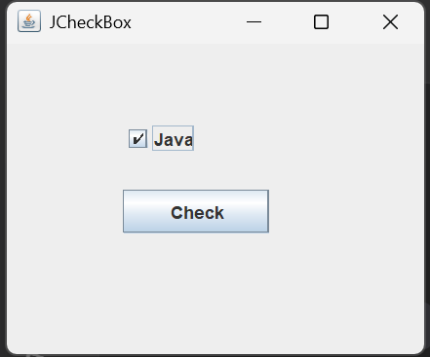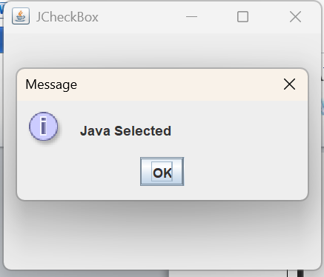
JRadioButton
It is a Swing component that allows the user to select one option from a group of mutually exclusive options.

import javax.swing.*;

public class RadioButtonExample {
public static void main(String[] args) {
JFrame f = new JFrame("JRadioButton");

JRadioButton r1 = new JRadioButton("Male");
JRadioButton r2 = new JRadioButton("Female");

r1.setBounds(50, 50, 100, 30);
r2.setBounds(50, 90, 100, 30);

ButtonGroup g = new ButtonGroup();
// only one radio button can be selected at a time
g.add(r1);
g.add(r2);

f.add(r1);
f.add(r2);

f.setSize(300, 250);
f.setLayout(null);
f.setVisible(true);
f.setDefaultCloseOperation(JFrame.EXIT_ON_CLOSE);
}
}

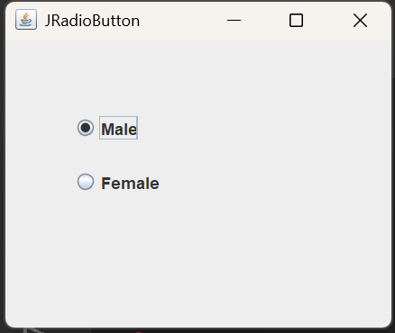
JComboBox
It is a Swing component that displays a drop-down list from which the user can select an item.

import javax.swing.*;

public class ComboBoxExample {
public static void main(String[] args) {
JFrame f = new JFrame("JComboBox");

String[] courses = {"Java", "Python", "C++"};

JComboBox<String> c = new JComboBox<>(courses);
c.setBounds(80, 50, 150, 30);

JButton b = new JButton("Show");
b.setBounds(100, 100, 100, 30);

b.addActionListener(e ->
JOptionPane.showMessageDialog(f, c.getSelectedItem())
);

f.add(c);
f.add(b);

f.setSize(300, 250);
f.setLayout(null);
f.setVisible(true);
f.setDefaultCloseOperation(JFrame.EXIT_ON_CLOSE);
}
}

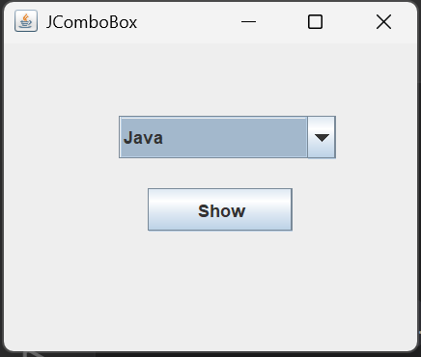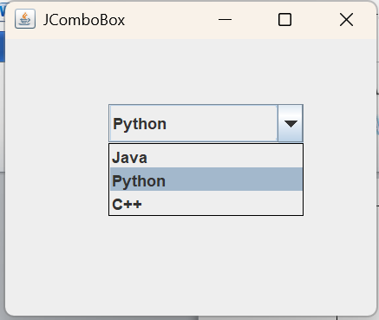

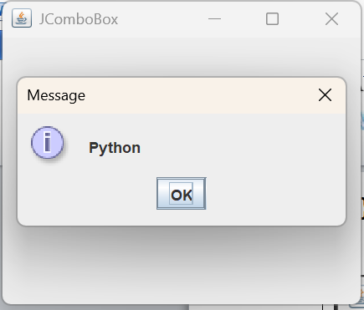
JTable
It is a Swing component that displays data in rows and columns, similar to a table.

import javax.swing.*;

public class TableExample {
public static void main(String[] args) {
JFrame f = new JFrame("JTable");

String[][] data = {
{"101", "Arun"},
{"102", "Ravi"},
{"103", "Kumar"}
};

String[] columns = {"ID", "Name"};

JTable table = new JTable(data, columns);

JScrollPane sp = new JScrollPane(table);
sp.setBounds(50, 50, 200, 100);

f.add(sp);

f.setSize(300, 250);
f.setLayout(null);
f.setVisible(true);
f.setDefaultCloseOperation(JFrame.EXIT_ON_CLOSE);
}
}

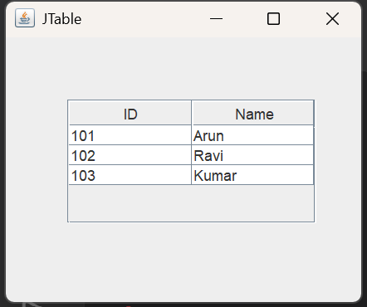
JList
It is a Swing component that displays a list of items from which the user can select one or more items.

import javax.swing.*;

public class ListExample {
public static void main(String[] args) {
JFrame f = new JFrame("JList");

String[] subjects = {"Java", "DBMS", "Python", "C"};

JList<String> list = new JList<>(subjects);
list.setBounds(80, 40, 120, 100);

f.add(list);

f.setSize(300, 250);
f.setLayout(null);
f.setVisible(true);
f.setDefaultCloseOperation(JFrame.EXIT_ON_CLOSE);
}
}

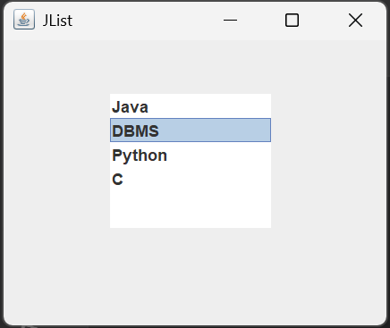
JOptionPane
It is a Swing component that provides ready-made dialog boxes for displaying messages, getting input, and asking for confirmation.

Output Example
import javax.swing.*;

public class OptionPaneExample {
public static void main(String[] args) {

JOptionPane.showMessageDialog(null,"Hello Java");
// showMessageDialog(parent, message)
}
}

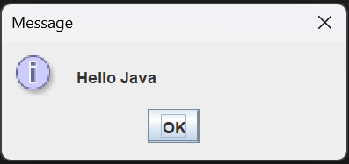

Input Example
import javax.swing.*;

public class OptionPaneInput {
public static void main(String[] args) {

String name = JOptionPane.showInputDialog("Enter your name");
// gets input from the user

JOptionPane.showMessageDialog(null, "Hello " + name);
}
}

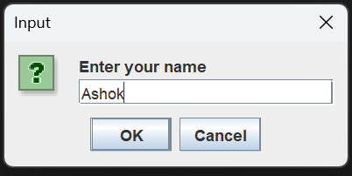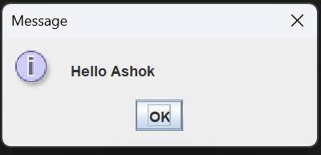
JScrollBar
It is a Swing component that allows the user to scroll vertically or horizontally through content.

import javax.swing.*;

public class ScrollBarExample {
public static void main(String[] args) {
JFrame f = new JFrame("JScrollBar");

JScrollBar s = new JScrollBar();
// JScrollBar s = new JScrollBar(JScrollBar.HORIZONTAL)
s.setBounds(100, 50, 20, 150);

f.add(s);

f.setSize(300, 250);
f.setLayout(null);
f.setVisible(true);
f.setDefaultCloseOperation(JFrame.EXIT_ON_CLOSE);
}
}

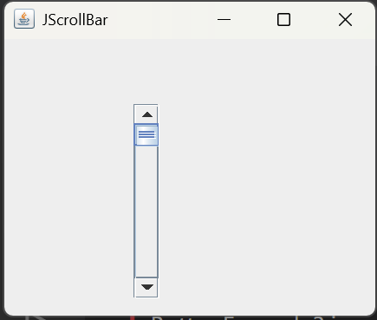
JMenu and JMenuItem
JMenu: It is a Swing component that represents a menu containing a list of menu items.

JMenuItem: It is a Swing component that represents an individual option or command within a menu.

import javax.swing.*;

public class MenuExample {
public static void main(String[] args) {
JFrame f = new JFrame("Menu");

JMenuBar bar = new JMenuBar();

JMenu file = new JMenu("File");

JMenuItem open = new JMenuItem("Open");
JMenuItem exit = new JMenuItem("Exit");

file.add(open);
file.add(exit);

bar.add(file);

f.setJMenuBar(bar);

open.addActionListener(e ->
JOptionPane.showMessageDialog(f, "Open Clicked")
);

exit.addActionListener(e ->System.exit(0));

f.setSize(300, 250);
f.setVisible(true);
f.setDefaultCloseOperation(JFrame.EXIT_ON_CLOSE);
}
}

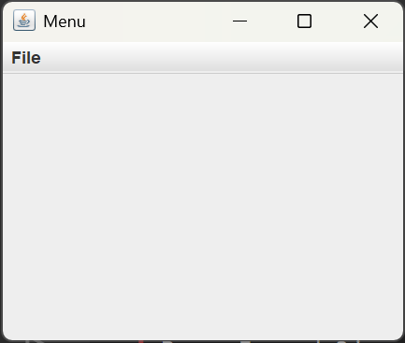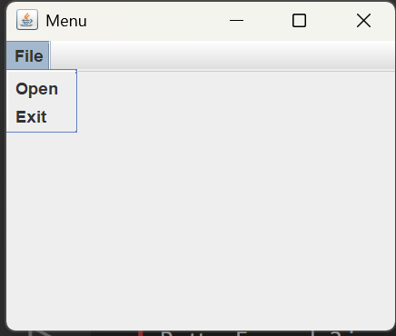

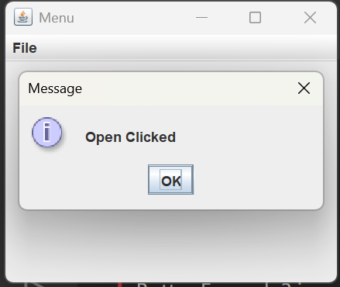
JPopupMenu
It is a Swing component that displays a small pop-up menu containing options when triggered by the user.

import javax.swing.*;
import java.awt.event.*;

public class PopupExample {
public static void main(String[] args) {
JFrame f = new JFrame("JPopupMenu");

JTextArea a = new JTextArea();
a.setBounds(50, 50, 200, 100);

JPopupMenu menu = new JPopupMenu();

JMenuItem copy = new JMenuItem("Copy");
JMenuItem paste = new JMenuItem("Paste");

menu.add(copy);
menu.add(paste);

a.setComponentPopupMenu(menu);

f.add(a);

f.setSize(300, 250);
f.setLayout(null);
f.setVisible(true);
f.setDefaultCloseOperation(JFrame.EXIT_ON_CLOSE);
}
}

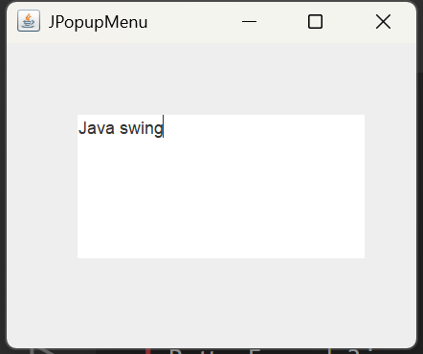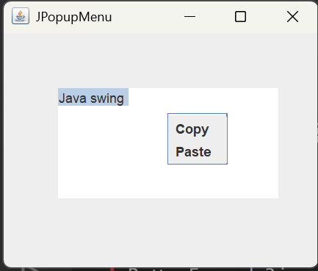
JCheckBoxMenuItem
It is a Swing menu component that allows the user to select or deselect an option using a check mark.

import javax.swing.*;

public class CheckBoxMenuExample {
public static void main(String[] args) {
JFrame f = new JFrame("JCheckBoxMenuItem");

JMenuBar bar = new JMenuBar();
JMenu view = new JMenu("View");

JCheckBoxMenuItem dark =
new JCheckBoxMenuItem("Dark Mode");

view.add(dark);
bar.add(view);

f.setJMenuBar(bar);

f.setSize(300, 250);
f.setVisible(true);
f.setDefaultCloseOperation(JFrame.EXIT_ON_CLOSE);
}
}

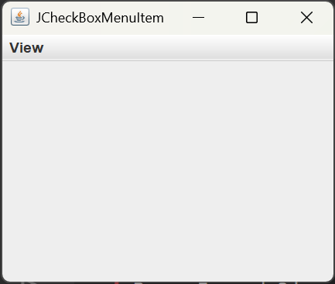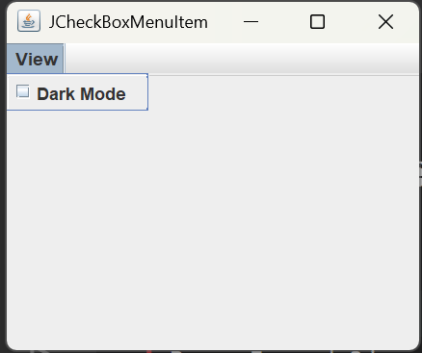
JSeparator
It is a Swing component that provides a horizontal or vertical line to visually separate GUI components.

import javax.swing.*;

public class SeparatorExample {
public static void main(String[] args) {
JFrame f = new JFrame("JSeparator");

JMenuBar bar = new JMenuBar();
JMenu file = new JMenu("File");

JMenuItem open = new JMenuItem("Open");
JMenuItem save = new JMenuItem("Save");
JMenuItem exit = new JMenuItem("Exit");

file.add(open);
file.add(save);

file.addSeparator();

file.add(exit);

bar.add(file);

f.setJMenuBar(bar);

f.setSize(300, 250);
f.setVisible(true);
f.setDefaultCloseOperation(JFrame.EXIT_ON_CLOSE);
}
}

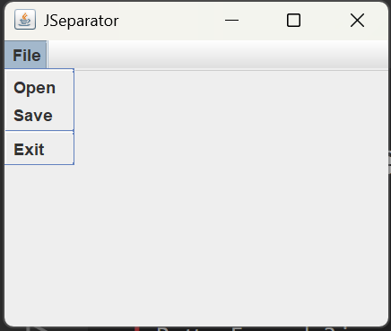
JProgressBar
It is a Swing component that visually shows the progress of a task.

import javax.swing.*;

public class ProgressBarExample {
public static void main(String[] args) {
JFrame f = new JFrame("JProgressBar");

JProgressBar p = new JProgressBar();
p.setBounds(50, 80, 200, 30);

p.setValue(70);

f.add(p);

f.setSize(300, 250);
f.setLayout(null);
f.setVisible(true);
f.setDefaultCloseOperation(JFrame.EXIT_ON_CLOSE);
}
}

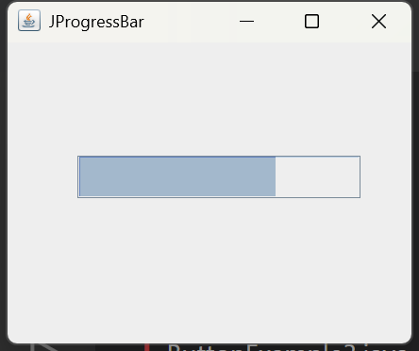
JTree
It is a Swing component that displays hierarchical data in a tree-like structure with expandable and collapsible nodes.

import javax.swing.*;

public class TreeExample {
public static void main(String[] args) {
JFrame f = new JFrame("JTree");

JTree tree = new JTree();

tree.setBounds(50, 30, 200, 150);

f.add(tree);

f.setSize(300, 250);
f.setLayout(null);
f.setVisible(true);
f.setDefaultCloseOperation(JFrame.EXIT_ON_CLOSE);
}
}

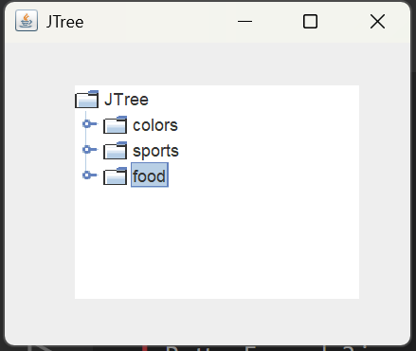

Component | Main purpose
JButton | Button
JLabel | Display text
JTextField | Single-line input
JPasswordField | Password input
JTextArea | Multiple-line input
JCheckBox | Select/deselect
JRadioButton | Select one option
JComboBox | Drop-down list
JTable | Rows and columns
JList | List of items
JOptionPane | Dialog box
JScrollBar | Scroll bar
JMenu | Menu
JMenuItem | Item inside menu
JPopupMenu | Right-click menu
JCheckBoxMenuItem | Checkbox inside menu
JSeparator | Separating line
JProgressBar | Progress indicator
JTree | Hierarchical data

JColorChooser
It is a Swing component that allows the user to select a color from a color selection dialog box.

import javax.swing.*;
import java.awt.*;

public class ColorChooserExample {
public static void main(String[] args) {
JFrame f = new JFrame("JColorChooser");

JButton b = new JButton("Choose Color");
b.setBounds(80, 80, 150, 40);

b.addActionListener(e -> {
Color c = JColorChooser.showDialog(f, "Select Color", Color.WHITE);
f.getContentPane().setBackground(c);
});

f.add(b);

f.setSize(300, 250);
f.setLayout(null);
f.setVisible(true);
f.setDefaultCloseOperation(JFrame.EXIT_ON_CLOSE);
}
}

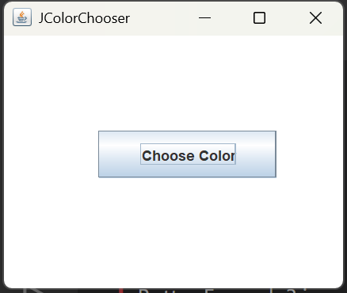

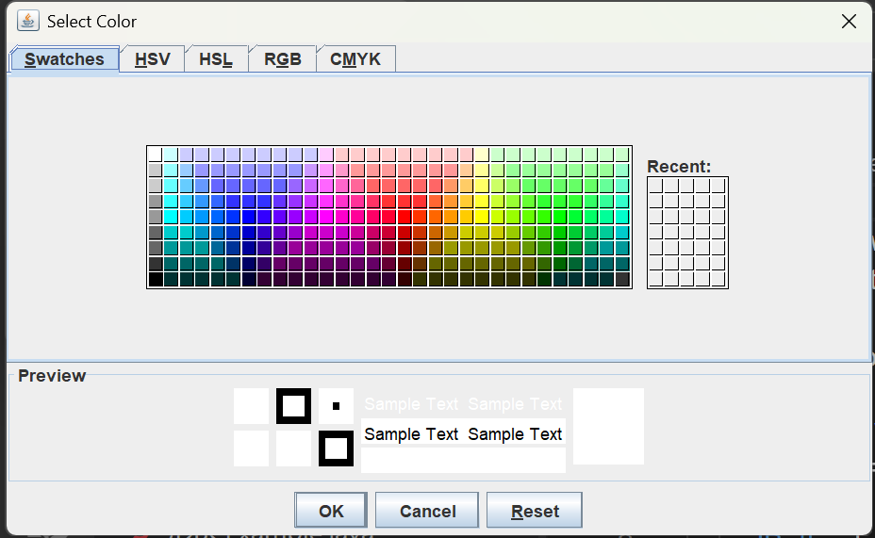

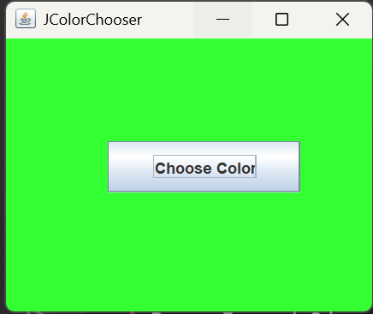
JTabbedPane
It is a Swing component that allows multiple panels to be organized and displayed using tabs

import javax.swing.*;

public class TabbedPaneExample {
public static void main(String[] args) {
JFrame f = new JFrame("JTabbedPane");

JTabbedPane tabs = new JTabbedPane();

JLabel l1 = new JLabel("This is Home");
JLabel l2 = new JLabel("This is Profile");
JLabel l3 = new JLabel("This is Settings");

tabs.addTab("Home", l1);
tabs.addTab("Profile", l2);
tabs.addTab("Settings", l3);

f.add(tabs);

f.setSize(400, 300);
f.setVisible(true);
f.setDefaultCloseOperation(JFrame.EXIT_ON_CLOSE);
}
}

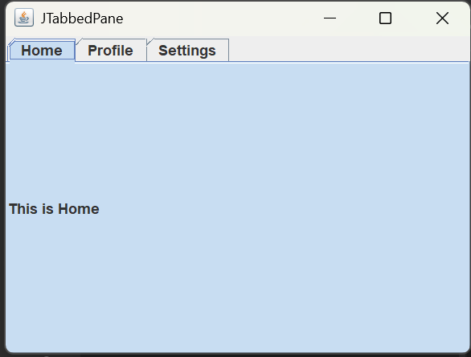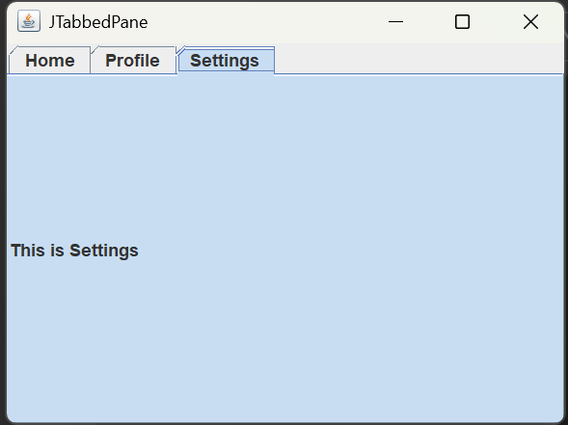
JSlider
It is a Swing component that allows the user to select a value by moving a slider knob along a range.

import javax.swing.*;

public class SliderExample {
public static void main(String[] args) {
JFrame f = new JFrame("JSlider");

JSlider s = new JSlider(0, 100, 50);
s.setBounds(50, 70, 250, 40);

f.add(s);

f.setSize(350, 200);
f.setLayout(null);
f.setVisible(true);
f.setDefaultCloseOperation(JFrame.EXIT_ON_CLOSE);
}
}
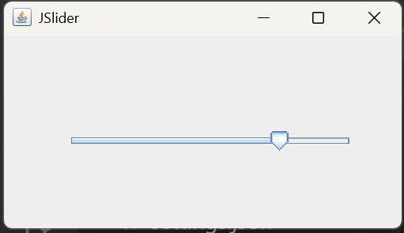
JSpinner
It is a Swing component that allows the user to select a value by clicking the up/down arrow buttons

import javax.swing.*;

public class SpinnerExample {
public static void main(String[] args) {
JFrame f = new JFrame("JSpinner");

JSpinner s = new JSpinner();
s.setBounds(100, 70, 100, 30);

f.add(s);

f.setSize(300, 200);
f.setLayout(null);
f.setVisible(true);
f.setDefaultCloseOperation(JFrame.EXIT_ON_CLOSE);
}
}

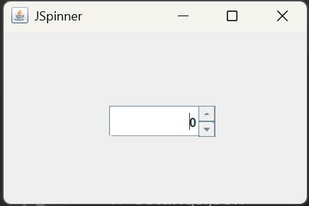
JDialog
It is a Swing dialog window that appears separately from the main JFrame

import javax.swing.*;

public class DialogExample {
public static void main(String[] args) {
JFrame f = new JFrame("JFrame");

JButton b = new JButton("Open Dialog");
b.setBounds(80, 70, 150, 40);

b.addActionListener(e -> {
JDialog d = new JDialog(f, "My Dialog");
d.setSize(250, 150);
d.setVisible(true);
});

f.add(b);

f.setSize(300, 250);
f.setLayout(null);
f.setVisible(true);
f.setDefaultCloseOperation(JFrame.EXIT_ON_CLOSE);
}
}

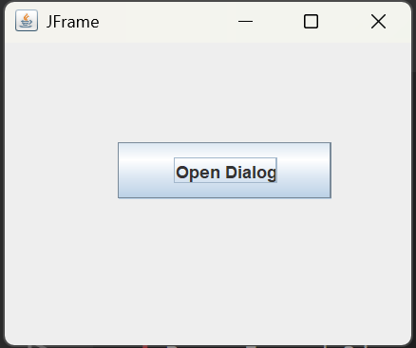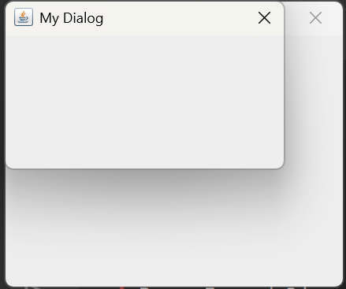
JPanel
JPanel is a Swing container used to hold and organize other Swing components such as buttons, labels, text fields, etc.

import javax.swing.*;

public class PanelExample {
public static void main(String[] args) {
JFrame f = new JFrame("JPanel");

JPanel p = new JPanel();

JButton b = new JButton("Click");
JLabel l = new JLabel("Hello");

p.add(b);
p.add(l);

f.add(p);

f.setSize(300, 200);
f.setVisible(true);
f.setDefaultCloseOperation(JFrame.EXIT_ON_CLOSE);
}
}

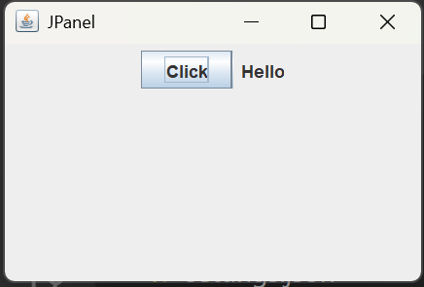
JFileChooser
import javax.swing.*;

public class FileChooserExample {
public static void main(String[] args) {
JFrame f = new JFrame("JFileChooser");

JButton b = new JButton("Choose File");
b.setBounds(80, 70, 150, 40);

b.addActionListener(e -> {
JFileChooser fc = new JFileChooser();
fc.showOpenDialog(f);
});

f.add(b);

f.setSize(300, 200);
f.setLayout(null);
f.setVisible(true);
f.setDefaultCloseOperation(JFrame.EXIT_ON_CLOSE);
}
}
JToggleButton
import javax.swing.*;

public class ToggleButtonExample {
public static void main(String[] args) {
JFrame f = new JFrame("JToggleButton");

JToggleButton b = new JToggleButton("OFF");
b.setBounds(80, 70, 120, 40);

b.addActionListener(e -> {
if (b.isSelected())
b.setText("ON");
else
b.setText("OFF");
});

f.add(b);

f.setSize(300, 200);
f.setLayout(null);
f.setVisible(true);
f.setDefaultCloseOperation(JFrame.EXIT_ON_CLOSE);
}
}
JToolBar
import javax.swing.*;

public class ToolBarExample {
public static void main(String[] args) {
JFrame f = new JFrame("JToolBar");

JToolBar bar = new JToolBar();

JButton b1 = new JButton("New");
JButton b2 = new JButton("Save");

bar.add(b1);
bar.add(b2);

f.add(bar, "North");

f.setSize(400, 250);
f.setVisible(true);
f.setDefaultCloseOperation(JFrame.EXIT_ON_CLOSE);
}
}
JViewport
import javax.swing.*;

public class ViewportExample {
public static void main(String[] args) {
JFrame f = new JFrame("JViewport");

JTextArea area = new JTextArea(10, 30);

JViewport viewport = new JViewport();
viewport.setView(area);

f.add(viewport);

f.setSize(300, 200);
f.setVisible(true);
f.setDefaultCloseOperation(JFrame.EXIT_ON_CLOSE);
}
}
JFrame
import javax.swing.*;

public class FrameExample {
public static void main(String[] args) {

JFrame f = new JFrame("My Application");

f.setSize(400, 300);
f.setVisible(true);

f.setDefaultCloseOperation(JFrame.EXIT_ON_CLOSE);
}
}
JComponent
import javax.swing.*;
import java.awt.*;

public class ComponentExample extends JComponent {

public void paintComponent(Graphics g) {
g.drawString("Hello Swing", 50, 50);
}

public static void main(String[] args) {
JFrame f = new JFrame("JComponent");

ComponentExample c = new ComponentExample();

f.add(c);

f.setSize(300, 200);
f.setVisible(true);
f.setDefaultCloseOperation(JFrame.EXIT_ON_CLOSE);
}
}
JLayeredPane
import javax.swing.*;

public class LayeredPaneExample {
public static void main(String[] args) {
JFrame f = new JFrame("JLayeredPane");

JLayeredPane lp = new JLayeredPane();

JButton b1 = new JButton("Button 1");
JButton b2 = new JButton("Button 2");

b1.setBounds(50, 50, 120, 50);
b2.setBounds(100, 80, 120, 50);

lp.add(b1, Integer.valueOf(1));
lp.add(b2, Integer.valueOf(2));

f.add(lp);

f.setSize(300, 250);
f.setVisible(true);
f.setDefaultCloseOperation(JFrame.EXIT_ON_CLOSE);
}
}
JDesktopPane
import javax.swing.*;

public class DesktopPaneExample {
public static void main(String[] args) {
JFrame f = new JFrame("JDesktopPane");

JDesktopPane desktop = new JDesktopPane();

JInternalFrame window = new JInternalFrame(
"Internal Window",
true,
true,
true,
true
);

window.setSize(200, 150);
window.setVisible(true);

desktop.add(window);

f.add(desktop);

f.setSize(400, 300);
f.setVisible(true);
f.setDefaultCloseOperation(JFrame.EXIT_ON_CLOSE);
}
}
JEditorPane
import javax.swing.*;

public class EditorPaneExample {
public static void main(String[] args) {
JFrame f = new JFrame("JEditorPane");

JEditorPane e = new JEditorPane();

e.setContentType("text/html");

e.setText(
"<html><h1>Hello</h1>" +
"<p>This is HTML</p></html>"
);

f.add(e);

f.setSize(400, 300);
f.setVisible(true);
f.setDefaultCloseOperation(JFrame.EXIT_ON_CLOSE);
}
}
JScrollPane
import javax.swing.*;

public class ScrollPaneExample {
public static void main(String[] args) {
JFrame f = new JFrame("JScrollPane");

JTextArea area = new JTextArea();

JScrollPane sp = new JScrollPane(area);

f.add(sp);

f.setSize(300, 250);
f.setVisible(true);
f.setDefaultCloseOperation(JFrame.EXIT_ON_CLOSE);
}
}
JSplitPane
import javax.swing.*;

public class SplitPaneExample {
public static void main(String[] args) {
JFrame f = new JFrame("JSplitPane");

JLabel l1 = new JLabel("Left");
JLabel l2 = new JLabel("Right");

JSplitPane split = new JSplitPane(
JSplitPane.HORIZONTAL_SPLIT,
l1,
l2
);

f.add(split);

f.setSize(400, 250);
f.setVisible(true);
f.setDefaultCloseOperation(JFrame.EXIT_ON_CLOSE);
}
}
JTextPane
import javax.swing.*;

public class TextPaneExample {
public static void main(String[] args) {
JFrame f = new JFrame("JTextPane");

JTextPane p = new JTextPane();

p.setText("This is JTextPane");

f.add(p);

f.setSize(300, 200);
f.setVisible(true);
f.setDefaultCloseOperation(JFrame.EXIT_ON_CLOSE);
}
}
JRootPane
import javax.swing.*;

public class RootPaneExample {
public static void main(String[] args) {
JFrame f = new JFrame("JRootPane");

JRootPane root = f.getRootPane();

JLabel l = new JLabel("Hello");

root.getContentPane().add(l);

f.setSize(300, 200);
f.setVisible(true);
f.setDefaultCloseOperation(JFrame.EXIT_ON_CLOSE);
}
}
Using ToolTip
import javax.swing.*;

public class ToolTipExample {
public static void main(String[] args) {
JFrame f = new JFrame("ToolTip");

JButton b = new JButton("Save");

b.setToolTipText("Click to save the file");

f.add(b);

f.setSize(300, 200);
f.setVisible(true);
f.setDefaultCloseOperation(JFrame.EXIT_ON_CLOSE);
}
}
Change JFrame Title
import javax.swing.*;

public class TitleExample {
public static void main(String[] args) {

JFrame f = new JFrame();

f.setTitle("Student Application");

f.setSize(300, 200);
f.setVisible(true);
f.setDefaultCloseOperation(JFrame.EXIT_ON_CLOSE);
}
}
Change JFrame Icon
import javax.swing.*;

public class IconExample {
public static void main(String[] args) {

JFrame f = new JFrame("My Application");

ImageIcon icon = new ImageIcon("logo.png");

f.setIconImage(icon.getImage());

f.setSize(300, 200);
f.setVisible(true);
f.setDefaultCloseOperation(JFrame.EXIT_ON_CLOSE);
}
}
Digital Watch
import javax.swing.*;
import java.text.SimpleDateFormat;
import java.util.Date;

public class DigitalWatch {
public static void main(String[] args) {

JFrame f = new JFrame("Digital Watch");

JLabel l = new JLabel();
l.setBounds(80, 60, 200, 50);

Timer t = new Timer(1000, e -> {
Date d = new Date();

SimpleDateFormat format =
new SimpleDateFormat("HH:mm:ss");

l.setText(format.format(d));
});

t.start();

f.add(l);

f.setSize(300, 200);
f.setLayout(null);
f.setVisible(true);
f.setDefaultCloseOperation(JFrame.EXIT_ON_CLOSE);
}
}
Graphics in Swing
import javax.swing.*;
import java.awt.*;

public class GraphicsExample extends JPanel {

public void paintComponent(Graphics g) {
super.paintComponent(g);

g.drawLine(20, 20, 200, 20);

g.drawRect(50, 50, 100, 60);

g.drawOval(180, 50, 100, 60);
}

public static void main(String[] args) {

JFrame f = new JFrame("Graphics");

GraphicsExample p = new GraphicsExample();

f.add(p);

f.setSize(350, 250);
f.setVisible(true);
f.setDefaultCloseOperation(JFrame.EXIT_ON_CLOSE);
}
}
Displaying an Image
import javax.swing.*;

public class ImageExample {
public static void main(String[] args) {

JFrame f = new JFrame("Image");

ImageIcon image = new ImageIcon("flower.jpg");

JLabel l = new JLabel(image);

f.add(l);

f.setSize(400, 300);
f.setVisible(true);
f.setDefaultCloseOperation(JFrame.EXIT_ON_CLOSE);
}
}

Component | Simple purpose
JColorChooser | Select color
JTabbedPane | Create tabs
JSlider | Select value using slider
JSpinner | Select value using arrows
JDialog | Dialog window
JPanel | Container
JFileChooser | Select file
JToggleButton | ON/OFF button
JToolBar | Toolbar
JViewport | Displays part of a component
JFrame | Main window
JComponent | Base class for Swing components
JLayeredPane | Components in layers
JDesktopPane | Desktop area
JEditorPane | Display formatted/HTML content
JScrollPane | Provides scrolling
JSplitPane | Split window
JTextPane | Styled text
JRootPane | Root container of JFrame
ToolTip | Small help message
setTitle() | Change window title
setIconImage() | Change window icon
Digital Watch | Timer + JLabel
Graphics | Draw shapes
ImageIcon | Display image

